Sample of Mathematics Entrance Examination 2022

All questions on this paper must be answered.
Working must be shown for all stages of the questions.
Each correct response to the questions receives 2 marks.

- Find the HCF and LCM of each pair:
- 72 and 48
- 12 and 24
- 36 and 24
- 150 and 220 (2 marks)
- Evaluate the expressions:
$$\left(12\frac{2}{9}+24\frac{2}{3}-16\frac{2}{15}\right):\frac{467}{45}$$
- Evaluate each expressions:
a) (-3)⁵
b) $\left(\frac{1}{2}\right)$³
c) (-0,4)²
- d) $\left(-\frac{1}{5}\right)$⁴ (2 marks)
- Evaluate:
- X⁵*X⁸
X³
- Y⁷*Y⁹
Y⁵
- C¹²*C¹⁰
C²¹
- D¹⁸*D¹²
D¹⁵ (2 marks)

- Evaluate the expressions:
a) (x³)²
b) (x⁵)⁶
c) (x⁷)¹²
d) (x¹⁰)¹³ (2 marks)

- Rewrite the polynomials:
5x²-3x²-x² (2 marks)
- Simplify:
14a *$\frac{a+2}{7}$ – 25a² *$\frac{4-3a}{5}$ (2 marks)
- Solve the system:
$\left\{\begin{aligned}-5x+2y=10 \\ -7x+2y=18\end{aligned}\right.$ (2 marks)

- Solve the equations:
4x² + 10x – 6=0 (2 marks)
- Find the roots of the equations:
18 – (x – 5) (x – 4) = -x² (2 marks)

- Factorize:
X² + 4x – 5 (2 marks)

- Raise to power:
(a+b)² (2 marks)
- Solve the equations:
3x + $\frac{4}{x}$ =7 (2 marks)

- Calculate:
  - $\sqrt{4*9}$ (2 marks)
- Evaluate:
4^{1/3} *4^{1/6} (2 marks)
- Grace and Jack share $140 in the ratio 3:4. Work out the amount of money that Jack gets. (2 marks)
- What is 7% in decimal fraction? (2 marks)
- What is 20%of 96? (2 marks)
- In a sale, normal prices are reduced by 20%. Andrew bought a saddle for his horse in the sale. The sale price of the saddle was $220. Calculate the normal price of the saddle. (2 marks)
- The brick factory sent a brick order with four different trucks carrying the same amount of bricks to a construction company. The amount of fuel in the tanks of these trucks after leaving and returning back to the factory is shown in the table below. Accordingly, which truck consumes the least fuel? (2 marks)

 | Amount of fuel in the tank while leaving the factory (litres) | Amount of fuel in the tank while returning to the factory (litres)
Truck 1 | 3⁴ | 2⁵
Truck 2 | 2⁶ | 5²
Truck 3 | 4³ | 3³
Truck 4 | 7² | 2⁴

21. The picture shows a 20-cm ruler and its cover.
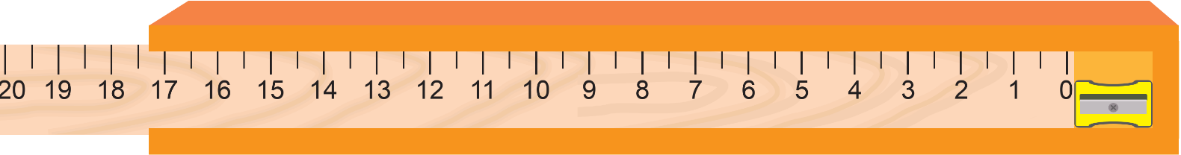
If a sharpener is placed first to the end of the cover and the ruler is placed afterwards, the case is as follows:

Based on this, what could be the length of the sharpener in cm? (2 marks)
- Tatami
Each small parallelogram contains the digits 1, 2 and 3. Each digit appears twice in each row and in each column of the big square. The same digit cannot appear horizontally or vertically next to itself, but it can appear diagonally next to itself. Fill in the figure.

3
3
3
2
3
3
(2 marks)

- Shape count
How many squares (of any size) are in this figure?
(2 marks)

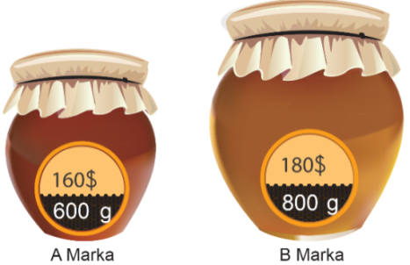
- Two types of honey (A and B) are sold in the market. Their weight and prices are shown below:

Type A Type B
The profits of the sales of type A honey and type B honey were the same in the past one week. Based on this, how many kilograms of both types of honey were sold for the past two weeks? (2 marks)

- A group of 15 friends went to the café. Each of the friends ordered one of the drinks shown in the menu. 2/5 of the group ordered ayron, 1/3 ordered fruit juice and the rest ordered lemonade. What is the total sum of their order?

Menu
Ayron 4 $
Juice 5 $
Lemonade 6 $
(2 marks)

- Place the given weights in the pans – one weight per pan - so that the scales balance.
Note: The weight of the rods and pans can be ignored; the stripes on each rod are exactly the same length.
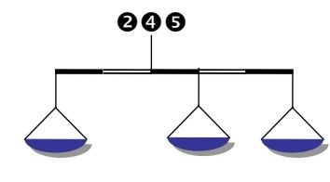

    - marks)

- What is the mirror image of the following text? (2 marks)

- B) c) d)

- Following the logical sequence, which of the answers matches the question mark (?) ?
- QPO, NML, KJI, __?__, EDC (2 marks)

A) XYZ B) CAB C) JKL D) HGF
29. Following the logical sequence in the picture, which of the answers matches the question mark (?) ? (2 marks)

- b) c) d)

30. One of the numbers below is the sum of two others. Find these three numbers. (2 marks)
